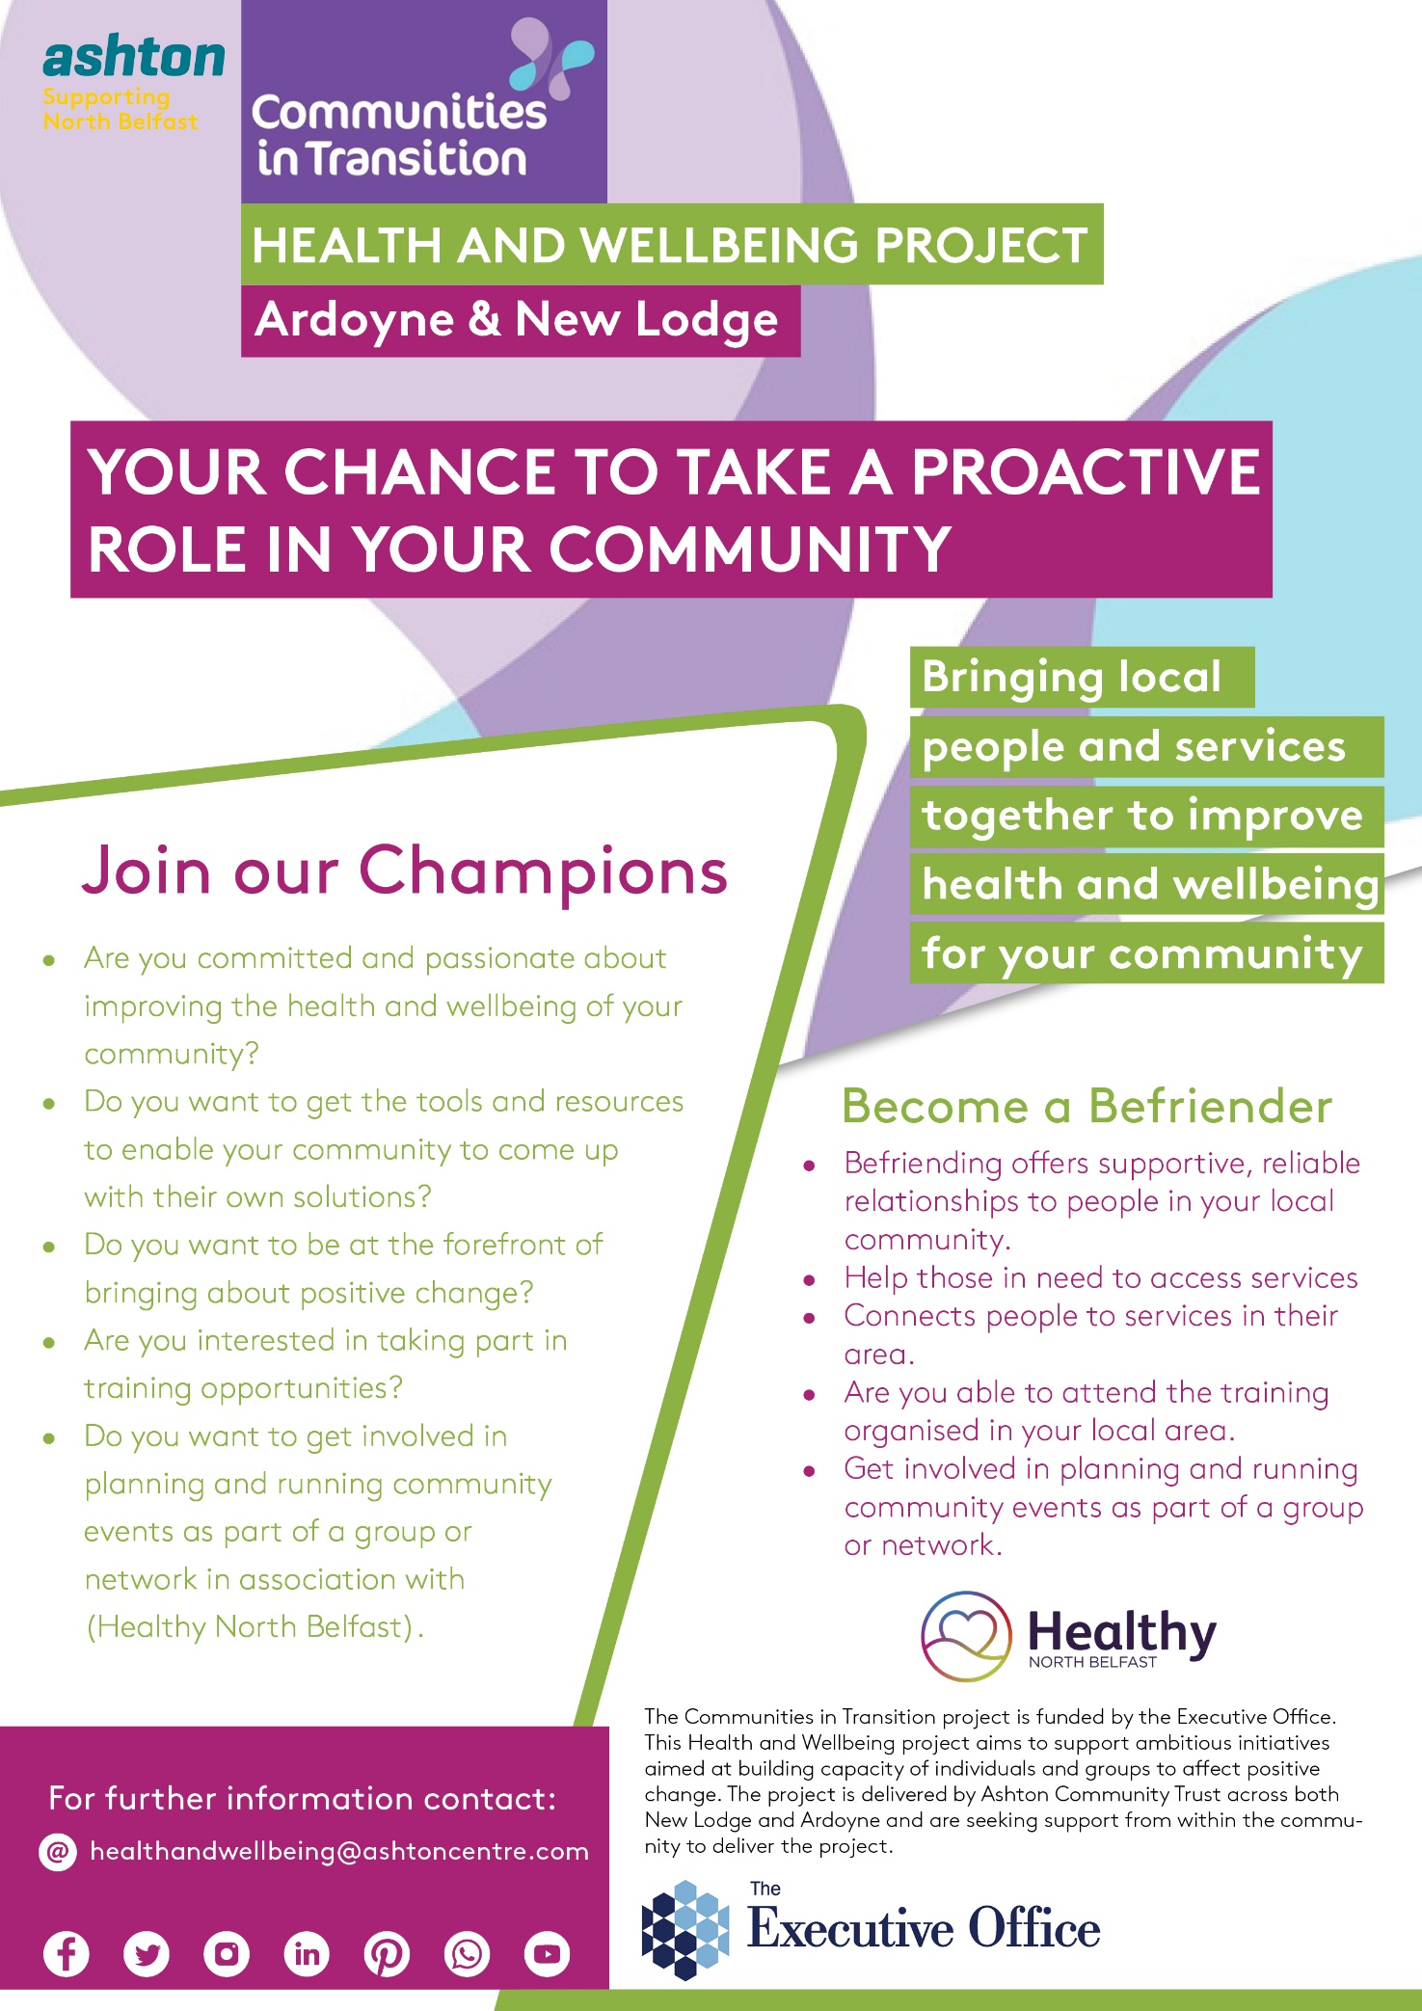

Communities in Transition Health and Well Being Programme.
Creating caring & compassionate communities. Phase II
Background

Ashton Community Trust has been awarded the contract for a Communities in Transition (CIT) Health and Wellbeing programme, Phase II situated in the North Belfast areas of New Lodge and Ardoyne.

The programme will include the active participation of Volunteers from within the North Belfast CIT Areas. The volunteers will be referred to as Community Champions and Befrienders. It is envisaged that the programme will recruit a minimum of 35 Community Champions and 35 Befrienders from across the New Lodge and Ardoyne CIT areas to actively participate in the Health and Wellbeing programme.

Champions must meet the following criteria:

- Be located in or have a substantial impact in the area;
- As an organization of group be constituted or be in the process of becoming constituted;
- As an individual be part of a constituted group or group be in the process of becoming constituted; and
- Exist for community benefit with their core work relating to health or wellbeing matters.

Individuals recruited to the programme as Befrienders must meet the following criteria:

- Live or work in the area; and
- Be committed to the health or wellbeing of the community.

The role of the Community Champions and Befrienders will be to play an active role in supporting existing services to address the Health and Wellbeing needs of the wider CIT North Belfast community. In addition, the Champions and Befrienders will assist with community engagement and health and wellbeing initiatives.

Following the training needs analysis both Befrienders and Community Champions will receive bespoke training prior to carrying out any programme activities if wanted. The training will empower both Befrienders and Community Champions to play an active role in response to Health and Wellbeing issues and to gain the ability to signpost people to relevant support and statutory services where appropriate. Training will include Mental Health First Aid.

Role of Community Champions and Befrienders

The Community Champions and Befrienders will support existing Services to address the Health and Wellbeing needs of the wider CIT North Belfast community.

The aim of the training will be to empower local people to play a more active role in improving their own Health and Wellbeing through making better, more informed choices and seeking to receive the help and support they require. In addition to the above requirements, the Community Champions will be provided with:

- Training to gain knowledge of a wide range of Health and Wellbeing issues to empower them to play a more active role in their community;
- Training to be able to provide basic level, non-medical advice and support in response to health and wellbeing issues; and
- Training to be able to signpost individuals who present with problems to the relevant support and statutory services where appropriate.

As a standard prerequisite, all Befrienders will be provided with suitable training to cover the following topics:

- peer mentoring;
- how to identify early indicators of mental health problems and wellbeing; and
- where to signpost for help and support services.

This training will assist in the establishing a befriending / mentoring / peer support programme that will involve cross-sections of the community in promoting resilience, reducing isolation and creating a better community for all its residents.

If you are interested in participating as a Champion or Befriender please complete the expression of interest section below and return via email to paul.barton@ashtoncentre.com
Alternatively, please post to Paul Barton, Ashton Community Trust, McSweeney Centre, 25-29 Henry Place, Belfast, BT15 2BB

Please note: Please tick one box only.

Please Tick: I am Interested in becoming a Community Champion Befriender
Contact Details:
Title:

Full Name:

Known as:
Address and Postcode:
Date of Birth
Email Address:
Telephone Number:
Organisation you currently work for, if any:

Training Needs Analysis

Please complete confidence level and need for training table below, mark each answer with a “X”.
Topic | Level of Confidence |  |  |  |  | Need for Training
 | Please rate your level of confidence in this area. |  |  |  |  | Please rate your level of need for training in this area.
 | Very  Confident | Somewhat Confident | Confident | Somewhat confident | Not at all Confident | No Need | Low Need | Moderate Need | High Need
Substance use & Addiction (Drugs/Alcohol)
Mental Health Awareness
Mental Health First Aid
Suicide Prevention & Self Harm.
Trauma informed Practice
Take 5 ‘Steps to Wellbeing’
Counselling Skills
Fitness / Physical Wellbeing
Nutrition
Autism Spectrum Condition
Safeguarding – Adult & Child Protection.
Data Protection & GDPR
Managing Risk / Assessment
Personal Debt / Money issues
Public Speaking / Presentation Training
Now to Access Local and National Services
Self-Care / Empowerment / Coping Skills
What training do you feel would be important to help you in your role as a community Champion or Befriender?

Signed: Print Name: Date:

