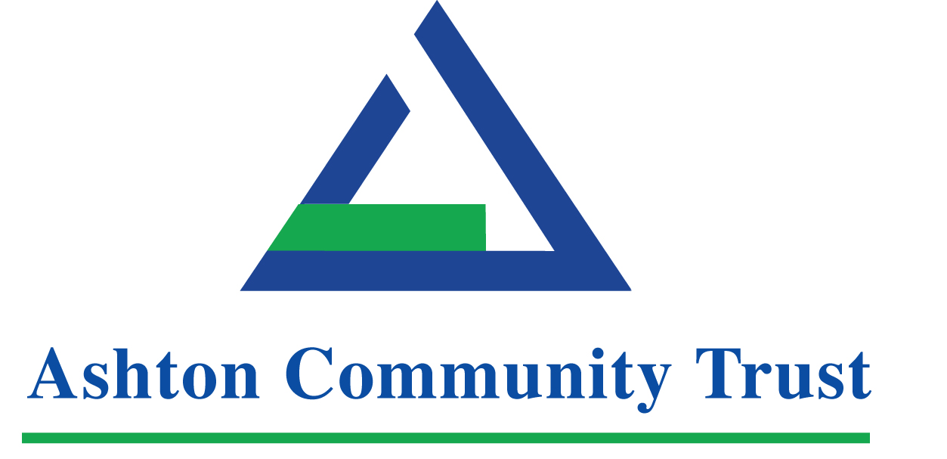

Invitation to Tender for the Evaluation of the
‘Breakthrough’

A project supported by the European Union’s PEACE IV Programme, managed by the Special EU Programmes Body (SEUPB).

The deadline for receipt of completed proposals is Friday 8th December 2017, 12noon.
Envelopes should be marked ‘Evaluation of Breakthrough PEACE IV Programme.’
The name and address of the person tendering should be shown on the envelope.

Terms of Reference

1 . Invitation to Submit Proposals
Ashton Community Trust invites tenders from qualified individuals and organisations to conduct a review and evaluation of the ‘Breakthrough’ PEACE IV Programme over a four year period from November 2017 to December 2021.

2. Introduction
Background
The ‘Breakthrough’ PEACE IV Programme is one of ten PEACE IV Children and Young People programmes funded within the community and voluntary sector as part of the Northern Ireland Executive’s ‘Together: Building A United Community’ Strategy. Supported by European Union’s PEACE IV Programme, managed by the Special EU Programmes Body (SEUPB), Breakthrough is an integrated good relations programme that provides flexible, high-quality, young-person-centered opportunities for 14–24 year olds. The young people targeted are the most disadvantaged / excluded / marginalised, who have deep social and emotional needs and from communities with sectarian divisions. The young people are identified as being at risk of becoming involved in anti-social behaviour, violence or dissident activity. This group is often excluded from opportunities enjoyed by their peer group and are at risk of social exclusion. They are not a homogenous group and are amongst the hardest to reach in society. This includes young people with disabilities, in need of mental health support, or support with alcohol/drug issues, lone parents, young people who have been in care, early school leavers, long term unemployed and those involved with Juvenile Justice/Probation.
The Programme
This holistic young person-centred approach aims to achieve sustainable, positive change in the lives of very marginalised young people enhancing their capacity to form positive and effective relationships with others of a different background and make a positive contribution to building a cohesive society. The project will bring young people from across the areas into a youth focused, co-designed programme that builds their confidence, abilities, experiences and widens their outlook on life. One-to-one mentoring and a range of group work activities, personal action plans, training and active community initiatives will cover PEACE IV’s three outcome areas of Personal Development, Good Relations and Citizenship.
Project Summary
Ashton Community Trust, as the lead organisation, secured funding to deliver the programme, engaging up to 172 young people living across North Belfast, Shankill and Newtownabbey working in local schools and in partnership with youth and community organisations. The programme will be delivered in partnership with Cliftonville Community Regeneration Forum, Ardoyne Youth Enterprises, Mount Vernon Community Development Forum (operating on behalf of Loughview Community Action Partnership), Newtownabbey Arts and Cultural Network (NACN), Street Beat, New Life City Church and YEHA Youth Project.
The geographical area covered by the project is divided along deeply entrenched sectarian lines. Segregated living is part of the spatial and social fabric with consequential mistrust of the other community. This project aims to bring young people together from each of these communities and to develop a respect of diversity.

This project will have a holistic young person centered approach, which aims to achieve sustainable, positive change enhancing young people’s capacity to form positive relationships with people from a different background and make a positive contribution to society.

The programme is focused on the belief that young people can grow and change and will provide the support they need to do so. The Programme will seek to understand and work with the wider context within which the young person lives their life; their family, community, social setting. Potential issues will be identified and goals set and an individual personal development action plan designed that considers all aspects of the young person’s needs.
The programme will have three distinct strands –
- Engagement with young people aged 14 – 17 years within school and in the community
- Youth centre based engagement with young people aged 14 – 18 years in the evenings
- Engagement with young people aged 16 – 24 years in the community.
3. Aim, Objectives and Outcome of Evaluation

Aim
To conduct an in-depth evaluation of the ‘Breakthrough’ PEACE IV Programme for internal use by Ashton Community Trust to inform future programmes. The evaluation will also be shared with SEUPB and the Quality and Impact Body, YouthPact, to demonstrate the operation and impacts of ‘Breakthrough’ and thus inform the Department’s external evaluation of the Children and Young People’s Programme. Results and findings will also be shared with partner organisations and other stakeholders.

The aim of YouthPact, the quality and impact body, is to work with delivery agents to support and enhance delivery and the quality of work with young people. The Quality and impact body will also work with delivery agents on the development and implementation of appropriate robust monitoring and measurement tools. This evaluator will work in conjunction with YouthPact on the use and implementation of these tools.

Objectives
Relevance and the Wider Context
- To carry out a review of the ‘Breakthrough’ PEACE IV Programme and document its operation and key activities undertaken;
- To assist with the development of an appropriate monitoring, measurement and evaluation system that will be implemented throughout the duration of the PEACE IV programme;
- To work with programme management to explore and implement a performance management system;
- To work alongside the Quality Impact Body YouthPact on the use and implementation of appropriate robust monitoring and measurement tools;
- To assess the impact of the programme, particularly the change supported for the young people taking part;
- To examine and document any factors which have influenced the impact and direction of the Programme, including its continuing relevance to the target young people;
- To review the changes and trends emerging in the environment and context in which this scheme operates (within youth work, voluntary and community, education, innovation and business and policy development) and how the project is positioned to respond;
- To examine the perception of this Programme within the sectors described above and within the target participants and groups.

NB. The evaluation should be precise in its description of how the Programme has created sustainable, positive change for the young people taking part with reference to the three PEACE IV Children and Young People’s Programme outcome areas of personal development, citizenship and good relations.

Requirements of the evaluation

(a) Programme Model

- To work alongside the Programme Management Team and the Quality Impact Body YouthPact to develop appropriate ‘youth friendly’ evaluation measurement tools and resources
- To document the operation and activities of the ‘Breakthrough’ PEACE IV Programme
- To review and evaluate;
- the recruitment process
- the participants’ experiences of the Programme
- the impact for individual participants – including interpretation and appropriate presentation of data concerned with individual progress / distance travelled
- the impact on family and the wider community
- progress towards Programme SMART objectives as outlined above
- development of this Programme over time in response to the needs and aspirations of participants
- unexpected outcomes of the programme activities
- key lessons learned from the experience of Programme delivery.
- To describe / present the Programme’s theory of change (including commentary on the underpinning youth centred or youth work approach - i.e. application of the principles)
- To explore and describe the role of the mentor and the impact of mentoring
- To capture the lessons learned from the Programme from participants, mentors and partner organisations
- To identify areas of best practice within the ‘Breakthrough’ PEACE IV Programme and in particular those areas which contributed most significantly to achievement of outcomes and other impacts. (This could usefully include how particular Programme activities have led to change – e.g. the mentor role, community involvement activities, volunteering experiences.)
- To examine the requirements of specific target groups when engaging with the project, and any barriers to engagement experienced by these users
- To explore participants’ views on the impact of features such as incentive payments made to participants and benefits flexibilities secured
- To prepare 10 participant case studies
- To explore the impact of the Programme on good relations in particular, providing an overview of the work and progress of the ‘Breakthrough’ PEACE IV Programme towards improving this.

- The evaluation should include the development of measurement tools to enhance assessment of needs and measure increases to include, mental health, drug and alcohol use

- Project Objectives, Impacts and Outputs
To carry out a review of the project and examine
  - the structure of Programme operation – e.g. days per week, hours per day, staff to participant ratio etc. – and what effect this had in terms of impact / change for participants
  - number of participants involved in the project
  - number of leavers and reasons for leaving
  - number of participants undertaking further training or education
  - the number and nature of courses and programmes that participants engaged with alongside their work with the Programme mentors
  - change in participants’ hopes and aspirations for the future
  - relationship with partners and engagement with other Agencies to aid Programme delivery

Outcomes
- To identify the peace and reconciliation effects of the approach and set out the implications of the project as a model of peace building in Northern Ireland.
- To make recommendations to Ashton Community Trust and project partners to inform future programmes

A report will be produced which includes presentation of the findings across the areas above, and recommendations to Ashton Community Trust and project partners in line with these findings.

4. Proposals
Proposals should describe:

- The approach to be adopted to each element of the project;
- The methodological issues arising and how these would be addressed;
- The project plan.

5. Research experience
The proposal should include details of relevant experience of similar research projects.

6. Budget
The successful tender will be awarded on a value for money basis, within a maximum budget of £14,000 across four years.

7. General Information required
- Name, address, telephone, e-mail and fax number of tenderer;
- Names of persons within tenderer’s business who will be working on the project;
- Name, address, telephone, e-mail and fax number of any third parties involved in the tender;
- Description of role or elements of contract to be fulfilled by any third party;
- Identification of party who will carry overall responsibility for the contract;
- Details of the qualifications and experience of each person who will be working on the project;
- Names of two referees familiar with the work of the tenderer.

8. Evaluation of Tenders and Award Criteria
The contract will be awarded from the qualifying tenders on the basis of the most economically advantageous tender applying the following award criteria:

Evaluation Criteria
Qualifying tenderers will be evaluated against the following criteria:
Criteria | Weighting
A) Demonstrated understanding of the scope of the project and ability to deliver the objectives and outputs of the project as outlined in this document;  B) Quality of proposed approach/methodology, with particular regard to best practice in evaluation and expertise of the tenderer in projects of a similar type;  C) Proposed project timetable for delivery and plan:  Detailed time line for the implementation of the project with allocated design, build and support time  D) Price:  Breakdown of costs per day, number of days allocated to each unit of activity. | 25%  25%  25%  25%
Total | 100%

The Price element of tenders will be assigned a score on the basis of a sliding scale. All tenders will be scored against the lowest proposed fixed cost with full marks (i.e. 25) being awarded to the party having submitted the lowest fixed cost tender.

Tenderer offering the lowest cost will be awarded full marks. All other tenderers will be awarded marks on a pro-rata basis depending on the total cost to complete project.

The approach to each element will be scored as follows:

Band | Scoring Basis | Marking out of 25
5 | Fully detailed evidence provided, very minor concerns on detail, relevance, accuracy or complexity | 21 - 25
4 | Detailed evidence provided, some minor concerns on detail, relevance, accuracy or complexity | 16 - 20
3 | Reasonable evidence provided, lacking in detail, relevance, accuracy or complexity | 11 – 15
2 | Limited evidence provided, significant concerns on detail, relevance, accuracy or complexity | 6 – 10
1 | Little or no evidence provided, very significant concerns on detail, relevance, accuracy or complexity | 1 – 5

9. Reporting
Researchers will report at designated stages of the project, to be agreed.

10. Timeframe
It is envisaged that this piece of work will start Mid December 2017 and finish by 31st December 2021.

11. Financial Arrangements
Payment for all services will be on foot of appropriate invoices in stage payments, invoicing arrangements will be agreed with the successful tenderer following the awarding of the contract. The following should also be noted:

- No additional fees except those originally quoted will be paid and additional costs will be a matter for the contractors themselves.

12. Ownership of Information
Ownership of data and reports related to the project will reside with Ashton Community Trust

13. Queries
Any queries concerning this document should be e-mailed to: corinna.mcerlean@ashtoncentre.com

A list of all appropriate questions received regarding the tender together with answers will be circulated to everyone who has registered 1 week before the deadline. After this date we will be unable to take questions on the process.

14. Proposals
Proposals - 2 hard copies should be sent by post or hand delivered to:

Katrina Newell
Head of Youth Development
Ashton Community Trust
5 Churchill Street
Belfast BT15 2BP

The deadline for receipt of completed proposals is 8th December 2017, 12 noon
Envelopes should be marked ‘Evaluation of Breakthrough Programme’
The name and address of the person tendering should be shown on the envelope.

